System Requirements Statement (SRS) –

Project Name

Created by : ABHIJEET KANHERE

: PRASAD NANGARLE

: ANUP POCHCHHI

Date : 26-JULY-2023

1. Introduction 3

2. Functional Requirements 4

2.1 ONLINE MEDICINE STORE ADMIN MODULE 5

2.2 ONLINE MEDICINE STORE USER MODULE 1 0

2.4 Use Case Diagram 18

THIS DOCUMENT CONTAINS 20 NUMBERED PAGES

# Introduction:

* It is a multi-role application project i.e. Admin and User, where Admin will have the main control over the system. Admin is the main role that will handle the overall application. Admin will be responsible for Adding/Removing/Updating medicine details in the system.
* This web application is developed to manage online medicine shops using an online automated system. It will help the store owner to track the medicine and inventory detail.
* Whereas Users can shop for required medicines, makes payments online, etc.

# Functional Requirements

|  |  |  |
| --- | --- | --- |
| **No** | **BRS requirement ID** | **Description** |
| **2.1** | **Module 1 Admin Module** | |
| **2.1.1** | **F1** | **Account Creation Process** |
| **2.1.2** | **F2** | **Login Process** |
| **2.1.3** | **F3** | **Forgot Password Process** |
| **2.1.4** | **F4** | **Change Password Process** |
| **2.1.5** | **F5** | **Update Account Process** |
| **2.1.6** | **F6** | **Track User Actions** |
| **2.1.7** | **F7** | **Manage Profile** |
| **2.2** | **Module 2 User Module** | |
| **2.2.1** | **F11** | **Account Creation Process** |
| **2.2.2** | **F12** | **Login Process** |
| **2.2.3** | **F13** | **Forgot Password Process** |
| **2.2.4** | **F14** | **Change Password Process** |
| **2.2.5** | **F15** | **Search The Medicine** |
| **2.2.6** | **F16** | **Find the Details of the Medicine** |
| **2.2.7** | **F17** | **Order The Product** |
| **2.2.8** | **F18** | **Cancel the Product** |
| **2.2.9** | **F19** | **Logout** |
| **2.3 Use Case Diagram** | | |
|  |  |  |
|  |  |  |
|  |  |  |

## Module 1

**Admin Module**: This module will allow Admin to log in to the system and manage the system and its functions. Admin can Add/Remove/Update medicines, manage medicines categories, details, and availability, can manage users, payments, etc.

Admin can add/remove stocks. Admin can track the sales activity and also, the growth of the store.

Admin.

* Admin can ADD/VIEW/UPDATE/DELETE Medicine Company.
* Admin can ADD/VIEW/UPDATE/DELETE Medicine detail.
* Admin can ADD/VIEW/UPDATE/DELETE medicine stocks.
* Admin can View/Confirm/Cancel order.
* Admin can manage payments.
* Admin can VIEW all the orders of medicine.
* Admin can manage “My Profile”.
* Can change password.

### Account Creation Process

Online Medicine store to create the account before using it. So, Online Medicine store provide the function which makes customer creates new account.

When customer creates new account, the function demands information described as below.

1. Registration

The Registration information consists of some items described as below.

1. First Name
2. Last name
3. E-mail ID
4. Password
5. User Type
   1. All items are compulsory demanded.
   2. First Name

* The First Name has constraints described as below.

1. Capital alphabet (A-Z)(first letter should be capital)
2. Small alphabet (a-z)(remaining letter should be small)
   1. Last Name

* The Last Name has constraints described as below.

1. Capital alphabet (A-Z)(first letter should be capital)
2. Small alphabet (a-z)(remaining letter should be small)
   1. E-mail ID

* If the Email ID Correspond with not case-sensitive to other which is previously registered, the Email-ID should not be registered as an account.
  1. Password
* The Password has constraints which makes the Password consists of more than or

Equal 8 and less than or equal 16 characteristics including characters described as below.

1. Numeric figure (at least one)
2. Capital alphabet (A-Z)(at least one)
3. Small alphabet (a-z)(at least one)
4. Special character (#, $, %, &, etc.) (at least one)

* The Password is masked by dummy characters. The re-entering Password is demanded.
* The Password must be encrypted in Restaurant Reservation System.

### Login Process

* Online Medicine store system always compels user authentication before using itself except when a new account is successfully created.
* The Login information
  1. Email-ID
  2. Password
* The user authentication demands Email-ID and Password. The Email-ID and the Password should be checked in three ways.
  1. First, The Email-ID and the Password should be existed and correct.
* If The Email-ID and the Password are not equal to what the user has registered, the user authentication cannot be provided.
  1. Second, the User Type linked to the Email-ID should be "Customer".
* When the User Type is "Customer" then user can be placed on “User’s Dashboard”.
  1. Finally, Email-ID should be available.
* The Administrator can decide whether the Email-ID is available or suspended – Refer to the SRS of the Admin part.
* If Customer registration is timed out, user authentication is not provided for system user.
  1. Password
* The Password has constraints which makes the Password consists of more than or equal 8 and less than or equal 16 characteristics including characters described as below.

1. Numeric figure (at least one)
2. Capital alphabet (A-Z)(at least one)
3. Small alphabet (a-z)(at least one)
4. Special character (#, $, %, &, etc.) (at least one)

* The Password is masked by dummy characters. The re-entering Password is demanded.
* The Password must be encrypted in Online Medicine Store System.
  1. The Online Medicine store system account should alive for so long as the duration decided by Admin.
  2. Only when all the checks are successfully completed, Online Medicine store system can be placed on respected page.
  3. The “Online Medicine Store System Dashboard” provides some of the features described as below.

1. A trigger to logout
2. A trigger to update Account
3. A trigger to Change Password
4. A trigger to Search medicines.
5. A trigger to Calculate Bill with Taxation.

### Forgot Password Process

* 1. First, system user enters their Email-ID for Online Medicine store system
  2. Next, Online Medicine store system demands the Email-ID which has been registered since when the Account was created.
  3. Only when the Recovery Code is correct, Customer get the new password by E-mail which has been registered since when the Account was created.
  4. The new password is automatically generated by Online Medicine store system.
* Of course, the new password should consist of more than or equal 8 and less than or equal 16 characteristics including at least a numeric figure, a capital alphabet, a small alphabet, and a special character.
* As a consequence, The Customer could get the customer authentication using the new password.
  1. Then, the customer had better change the new password manually.
* If the Recovery code is not correct, otherwise, the correct Recovery code is demanded for customer again.
  1. In that case, Of course, customer couldn’t get the new password.

### Change Password Process

* When customer wants to change their Password, the measure should be provided by Online Medicine store system
* Therefore, Online Medicine store system should provide the function which is available after getting the customer authentication.
* The function demands the current password and the new password.
  1. Of course, the new password should consist of more than or equal 8 and less than or equal 16 characteristics including at least a numeric figure, a capital alphabet, a small alphabet, and a special character.
  2. The current password and the new password are masked by using dummy characters.
  3. The new password is demanded to enter twice to avoid a typing error.
* Only when the current password is correct, customer could change their Password.
* When the current password is changed into new password, Online Medicine store system compels user authentication again.

### Update Account Process

* Online Medicine store system should provide the function which makes the account updated for customer.
* The information customer could update is described below.

1. Login information
2. User information

* The Login information

The updatable items as described below.

1. First Name
2. Last Name
3. E-mail address

* All items are compulsory demanded, but updating is optional.
* The User information

The updatable items as described below.

1. Customer Name
2. Customer Contact No
3. E-mail address

* All items are compulsory demanded, but updating is optional.

## Module 2

* **User Module :–**
* The user can log in/log out of the system. Users can search for medicines, view different medicines available, and can find detailed information on the system after logging in. Can log in/log out of the system.
* Can Manage “My profile”.
* Can search for medicines from a specific category.
* Can upload prescriptions.
* Users can Place/Cancel an order.
* Can make payments online.
* Can change password.

## 

### Account Creation Process

* Online Medicine store to create the account before using it. So, Online Medicine store provide the function which makes customer creates new account.
* When customer creates new account, the function demands information described as below.

1. Registration

* The Registration information consists of some items described as below.

1. First Name
2. Last name
3. E-mail ID
4. Password
5. User Type
   1. All items are compulsory demanded.
   2. First Name

* The First Name has constraints described as below.

1. Capital alphabet (A-Z)(first letter should be capital)
2. Small alphabet (a-z)(remaining letter should be small)
   1. Last Name

* The Last Name has constraints described as below.

1. Capital alphabet (A-Z)(first letter should be capital)
2. Small alphabet (a-z)(remaining letter should be small)
   1. E-mail ID

* If the Email ID correspond with not case-sensitive to other which is previously registered, the Email-ID should not be registered as an account.
  1. Password
* The Password has constraints which makes the Password consists of more than or

equal 8 and less than or equal 16 characteristics including characters described as below.

1. Numeric figure (at least one)
2. Capital alphabet (A-Z)(at least one)
3. Small alphabet (a-z)(at least one)
4. Special character (#, $, %, &, etc.) (at least one)

* The Password is masked by dummy characters. The re-entering Password is demanded.
* The Password must be encrypted in Restaurant Reservation System.

### Login Process

* Online Medicine store system always compels user authentication before using itself except when a new account is successfully created.
* The Login information
  1. Email-ID
  2. Password
* The user authentication demands Email-ID and Password. The Email-ID and the Password should be checked in three ways.
  1. First, The Email-ID and the Password should be existed and correct.
* If The Email-ID and the Password are not equal to what the user has registered, the user authentication cannot be provided.
  1. Second, the User Type linked to the Email-ID should be "Customer".
* When the User Type is "Customer",then user can be placed on “User’s Dashboard”.
  1. Finally, Email-ID should be available.
* The Administrator can decide whether the Email-ID is available or suspended – Refer to the SRS of the Admin part.
* If Customer registration is timed out, user authentication is not provided for system user.
  1. Password
* The Password has constraints which makes the Password consists of more than or equal 8 and less than or equal 16 characteristics including characters described as below.

1. Numeric figure (at least one)
2. Capital alphabet (A-Z)(at least one)
3. Small alphabet (a-z)(at least one)
4. Special character (#, $, %, &, etc.) (at least one)

* The Password is masked by dummy characters. The re-entering Password is demanded.
* The Password must be encrypted in Online Medicine store system.
  1. The Online Medicine store system account should alive for so long as the duration decided by Admin.
  2. Only when all the checks are successfully completed, Online Medicine store system can be placed on respected page.
  3. The “Online Medicine store system Dashboard” provides some of the features described as below.

1. A trigger to logout
2. A trigger to update Account
3. A trigger to Change Password
4. A trigger to Search medicines.
5. A trigger to Calculate Bill with Taxation.

### Forgot Password Process

* 1. First, system user enters their Email-ID for Online Medicine store system
  2. Next, Online Medicine store system demands the Email-ID which has been registered since when the Account was created.
  3. Only when the Recovery Code is correct, Customer get the new password by E-mail which has been registered since when the Account was created.
  4. The new password is automatically generated by Online Medicine store system.
* Of course, the new password should consist of more than or equal 8 and less than or equal 16 characteristics including at least a numeric figure, a capital alphabet, a small alphabet, and a special character.
* As a consequence, The Customer could get the customer authentication using the new password.
  1. Then, the customer had better change the new password manually.
* If the Recovery code is not correct, otherwise, the correct Recovery code is demanded for customer again.
  1. In that case, Of course, customer couldn’t get the new password.

### Change Password Process

* When customer wants to change their Password, the measure should be provided by Online Medicine store system
* Therefore, Online Medicine store system should provide the function which is available after getting the customer authentication.
* The function demands the current password and the new password.
  1. Of course, the new password should consist of more than or equal 8 and less than or equal 16 characteristics including at least a numeric figure, a capital alphabet, a small alphabet, and a special character.
  2. The current password and the new password are masked by using dummy characters.
  3. The new password is demanded to enter twice to avoid a typing error.
* Only when the current password is correct, customer could change their Password.
* When the current password is changed into new password, Online Medicine store system compels user authentication again.

### Update Account Process

* Online Medicine store system should provide the function which makes the account updated for customer.
* The information customer could update is described below.

1. Login information
2. User information

* The Login information

The updatable items as described below.

1. First Name
2. Last Name
3. E-mail address

* All items are compulsory demanded, but updating is optional.
* The User information

The updatable items as described below.

1. Customer Name
2. Customer Contact No
3. E-mail address

* All items are compulsory demanded, but updating is optional.

## Use Case Diagram:-

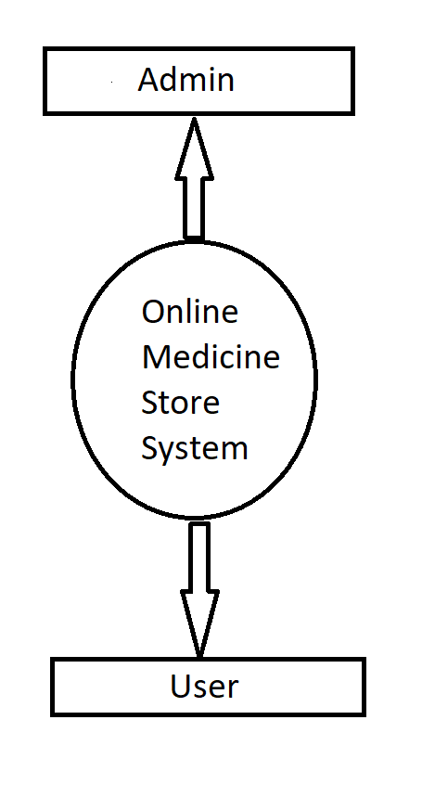

**System Functions:**

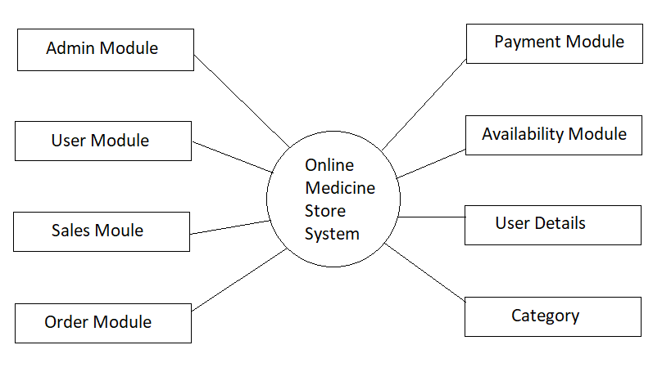

**Admin Module:**

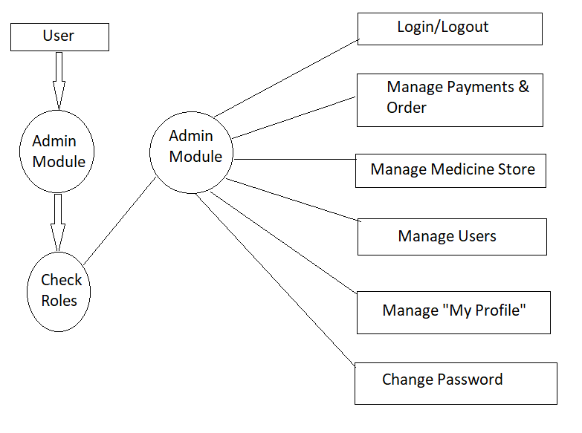

**User Module:**

\

